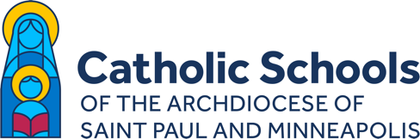

CATHOLIC SCHOOLS BRAND LAUNCH
COMMUNICATIONS TEMPLATES FOR SCHOOLS

MESSAGE TO SCHOOL FAMILIES
INCLUDE:
- Letter from Archbishop Bernard Hebda (English and Spanish versions available) [LOCATED IN FOLDER]
- Brand video (optional) [LOCATED IN FOLDER AND ON YOUTUBE: https://youtu.be/XHXAf6DGdcc]

Suggested text:

Dear SCHOOL NAME families,

We’re excited to share the following letter with you from Archbishop Bernard Hebda about a new brand identity for the 91 Catholic schools of the Archdiocese of Saint Paul and Minneapolis. This brand will complement our school’s distinct branding. Click here to watch a brief video about the brand.

We echo Archbishop Hebda in thanking you for partnering with us in your children’s Catholic education. God bless you!

Sincerely,
SCHOOL LEADER NAME

QUESTIONS? Contact Jessica Trygstad:
trygstadj@archspm.org
651-291-4431

