AGRA SCHOOL LUNCH PROGRAM MAY 2022 LUNCH CALENDAR

Monday | Tuesday | Wednesday | Thursday | Friday
2 | 3 | 4 | 5 | 6
● Agra Dog w/ Chips  ● Roasted Vegetable Sandwich w/ Chips  ● Turkey & Cheese Sandwich  ● Snap Peas  ● Cantaloupe | ● Spaghetti w/ Meat Sauce  ● Spaghetti w/ Tomato Sauce  ● Ham & Cheese Wrap  ● Zucchini (Green)  ● Honeydew  Extra: Smoothie – Banana Berry | ● Chicken Caesar Wrap w/ Cold Ham Pasta  ● Quinoa Veggie Wrap w/ Cold Chickpea Pasta  ● Basil Turkey BLT Sandwich  ● Baby Carrots  ● Watermelon | ● Taco Bowl  ● Black Bean Taco Bowl  ● Roasted Chicken & Cheese Sandwich  ● Corn  ● Apple Slices  Extra: Smoothie – Banana Berry | ● Chicken Teriyaki Bowl  ● Tofu Teriyaki Bowl  ● Turkey & Cheese Wrap  ● Squash (Yellow)  ● Orange Slices
9 | 10 | 11 | 12 | 13
● Grilled Cheese w/ Tomato Soup  ● Salami & Cheese Wrap  ● Broccoli  ● Honeydew | ● Agra Burger w/ Pretzels  ● Veggie Burger w/ Pretzels  ● Ham & Cheese Sandwich  ● Roasted Yams  ● Cantaloupe  Extra: Smoothie – Banana Berry | ● Pesto Pasta w/ Chicken  ● Pesto Pasta  ● Salami & Cheese Sandwich  ● Cauliflower Blend  ● Orange Slices | ● Chicken Fried Rice  ● Tofu Fried Rice  ● Basil Turkey BLT Sandwich  ● Peas & Carrot Blend  ● Watermelon  Extra: Smoothie – Banana Berry | ● Turkey Sloppy Joes w/ Chips  ● Quinoa Veggie Wrap w/ Chips  ● Ham & Cheese Wrap  ● Roasted Beets  ● Apple Slices
16 | 17 | 18 | 19 | 20
● Chicken Tenders w/ Roasted Potatoes  ● Roasted Vegetable Sandwich w/ Chips  ● Turkey & Cheese Sandwich  ● Green Beans  ● Orange Slices | ● Macaroni ‘N’ Cheese w/ Burger Bits  ● Macaroni ‘N’ Cheese  ● Roasted Chicken & Cheese Sandwich  ● Snap Peas  ● Honeydew  Extra: Smoothie – Banana Berry | ● Turkey Burger w/ Goldfish  ● Veggie Burger w/ Goldfish  ● Salami & Cheese Wrap  ● Baby Carrots  ● Cantaloupe | ● Chicken Noodle Soup w/ Bread Roll  ● Quinoa Veggie Wrap w/ Chips  ● Turkey & Cheese Wrap  ● Zucchini (Green)  ● Apple Slices  Extra: Smoothie – Banana Berry | ● Chicken Stir-Fry  ● Tofu Stir-Fry  ● Salami & Cheese Sandwich  ● Corn  ● Watermelon
23 | 24 | 25 | 26 | 27
● Chicken Tacos  ● Black Bean Tacos  ● Ham & Cheese Sandwich  ● Roasted Yams  ● Apple Slices | ● Grilled Chicken Sandwich w/ Chips  ● Roasted Vegetable Sandwich w/ Chips  ● Basil Turkey BLT Sandwich  ● Peas & Carrot Blend  ● Cantaloupe  Extra: Smoothie – Banana Berry | ● Spaghetti w/ Meat Sauce  ● Spaghetti w/ Tomato Sauce  ● Turkey & Cheese Sandwich  ● Roasted Beets  ● Honeydew | ● Chicken Wild Rice Soup w/ Bread Roll  ● Roasted Vegetable Sandwich w/ Chips  ● Ham & Cheese Wrap  ● Cauliflower Blend  ● Watermelon  Extra: Smoothie – Banana Berry | ● Southwest Chicken Wrap w/ Cold Ham Pasta  ● Quinoa Veggie Wrap w/ Cold Chickpea Pasta  ● Salami & Cheese Wrap  ● Broccoli  ● Orange Slices
30 | 31
● Chicken Fried Rice  ● Tofu Fried Rice  ● Turkey & Cheese Wrap  ● Squash (Yellow)  ● Honeydew | ● Agra Dog w/ Goldfish  ● Roasted Vegetable Sandwich w/ Goldfish  ● Roasted Chicken & Cheese Sandwich  ● Green Beans  ● Apple Slices  Extra: Smoothie – Banana Berry |  |  | ● Main Entrée  ● Vegetarian Entrée  ● Cold Sandwich Option  ● Vegetable Side  ● Fruit Side  *Cold Sandwich Option and some of Main Entrées are served with a side of chips, pretzels, goldfish, etc.
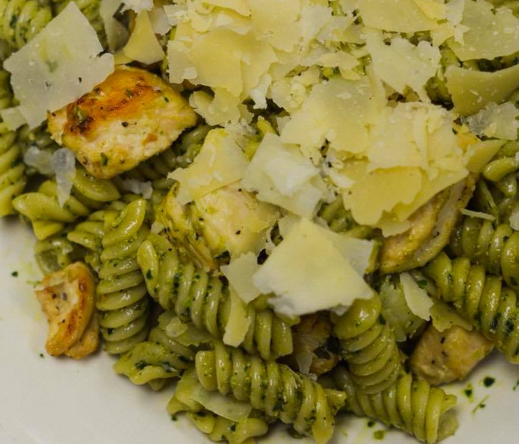
School Menu
Agra School LLC (Corporate Office) – 3717 W 50th Street – Minneapolis, MN 55410

